Task 2: Health Test log
Description of test | Test data to be used (if required) | Expected outcome | Actual outcome | Comments and intended actions
Testing form validation on Home Risk Assessment Page | Any combination of checked/unchecked boxes | User should be able to submit the form even if some checkboxes are not ticked | Form refused to submit unless all checkboxes were ticked | Incorrect use of required attribute. All checkboxes had required forcing the user to click everything.  Before:  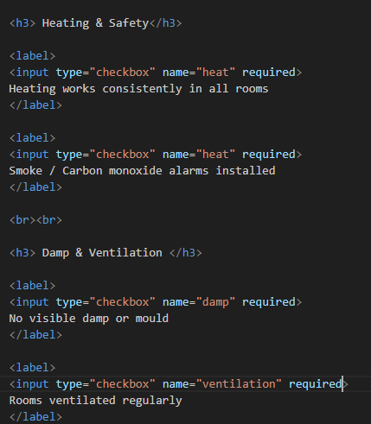  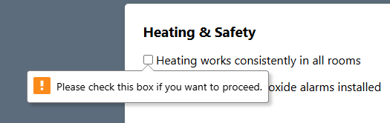  Fix: Removed required from all checkboxes  Retested and form submits correctly.
Testing form submission on Home Risk Assessment Page | No data required | Clicking “Submit” should reload the page and show advice | Nothing happened when clicking submit | Form was a .html file. Changed to risk_assessment.php and updated form action. Retested and working
Auto-scroll to results after submitting risk assessment | Any submission | Page should jump to results | User stayed at the top of the page | Missing anchor  Fix:  Retested and working
Navigation bar | None | All links load correct pages | Some links broken | Outdated file names  Fix: Updated file names  Retested and working
Test that advice card buttons on Health Advice page open correct NHS/external resources | None | Links should open in a new tab and load correct resource | All links opened correct pages | Works as intended
Weather forecast page | No data required | Page should load properly and show a message asking the user to enter a city | Multiple warnings, undefined array key, undefined variables $lat / $lon, missing forecast list | The page did not load before a city was searched.  Fix:  So, I wrapped all weather code inside  So that the weather code is only ran after a city has been searched
Testing API request using file_get_contents() on XAMPP | Valid API URL (OpenWeather forecast endpoint) | API response should load normally | XAMPP produced SSL errors and refused to load HTTPS and URLs | XAMPP on windows often blocks HTTPS requests due to missing SSL certificates.  Fix:  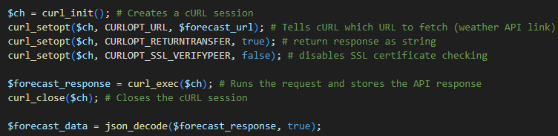  I switched to cURL to bypass SSL verification.  This fixed the issue and allowed the API to load successfully.
Add more rows and tables as required.

